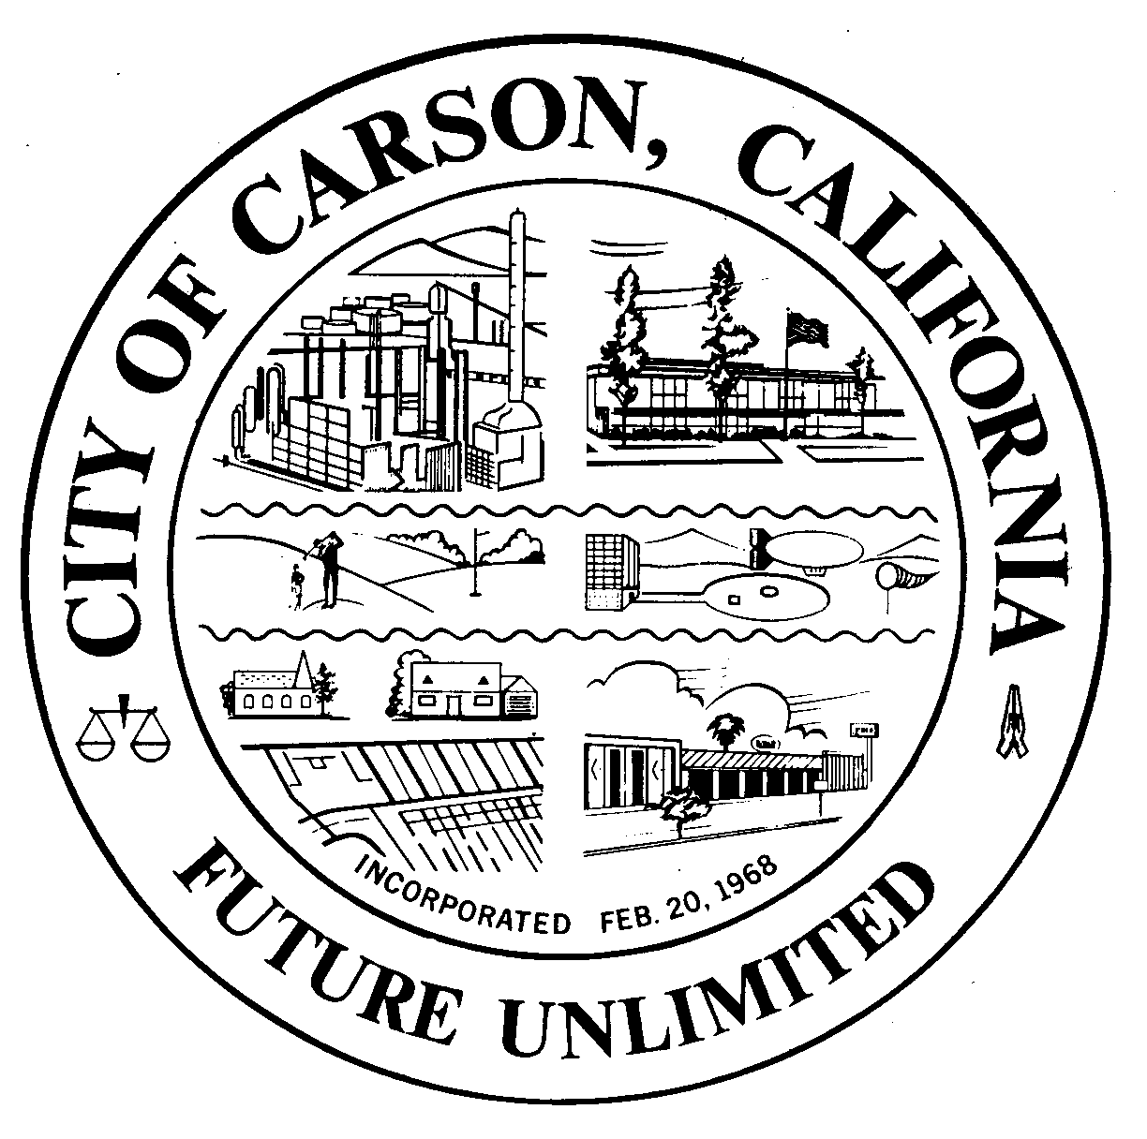
A G E N D A
CITY OF CARSON
REGULAR MEETING OF THE ENVIRONMENTAL COMMISSION
701 East Carson Street, Carson, CA 90745
EXECUTIVE CONFERENCE ROOM, 2ND FLOOR
Wednesday, November 6, 2013
6:30 p.m.

- CALL TO ORDER:

- PLEDGE OF ALLEGIANCE:

- ROLL CALL: Environmental Commissioners:
Burr, Hellerud, Hopson, Jimenez, Love, Mack, Muckey, Perry, Taylor
- AGENDA POSTING CERTIFICATION: In accordance with the Americans with
Disabilities Act of 1990, if you require a disability related modification or accommodation to attend or participate in this meeting, including auxiliary aids or services, please call the City Clerk’s office at 310-952-1720 at least 48 hours prior to the meeting. (Government Code Section 54954.2)
- AGENDA APPROVAL:
- ORAL COMMUNICATIONS: For items NOT on the agenda. Speakers are limited to three minutes.
- MINUTES APPROVAL:
  - September 4, 2013 and October 2, 2013
- UNFINISHED BUSINESS
a. Discuss the Environmental Commission’s logo, projects, and next steps toward the implementation of the Commission’s goals
- NEW BUSINESS
  - South Bay Cities Council of Governments Environmental Services Presentation, Role and Programs
- WRITTEN COMMUNICATIONS
  - Response to Comments on the Negative Declaration for the Rainbow Transport Tank Cleaners Interim Measures Work Plan, 21119 Wilmington Avenue
  - City Council Report Update on Rainbow Cleanup Efforts, 1119 Wilmington Avenue
  - South Bay Cities Council of Governments General Assembly February 28, 2014
  - HEAL Survey
___________________________________________________
- ORAL COMMUNICATIONS
  - Audience
  - Commissioners
  - Staff
    - Distribution of Business Cards
    - Stipend Forms
    - Date of the January Meeting, January 6, 2014
____________________________________________________________________________
- ADJOURNMENT
Upcoming Meetings: November 6, December 4, January 6, February 5, March 5, April 2, May 7

